Crawford Central School District
Cochranton and Meadville Extra-Curricular Activities
Resocialization of Activities Recommendations

These recommendations are based on the current guidelines characterized in the Green Phase. As more public health information is available, the administration may work with impacted entities to release further guidance which could impact fall, winter, or spring seasons. At this juncture, these guidelines apply to Athletics and Performing Arts with regard to off-season workout sessions that are not mandatory practices or public events. No spectators allowed.

INTRODUCTION

The COVID-19 pandemic has presented athletics across the world with a myriad of challenges. The COVID-19 virus is a highly contagious illness that primarily attacks the upper respiratory system. The virus that causes COVID-19 can infect people of all ages. Research from the Centers for Disease Control, among others, has found that while children do get infected by COVID-19, relatively few children with COVID-19 are hospitalized. However, some severe outcomes have been reported in children, and a child with a mild or even asymptomatic case of COVID-19 can spread the infection to others who may be far more vulnerable. While it is not possible to eliminate all risk of furthering the spread of COVID-19, the current science suggests there are many steps schools can take to reduce the risks to students, coaches, and their families.

The district will take the necessary precautions and recommendations from the federal, state, and local governments, CDC, PA DOH, as well as the NFHS and PIAA. The district realizes the knowledge regarding COVID-19 is constantly changing as new information and treatments become available. These recommendations will be adjusted as needed as new information becomes available in order to decrease the risk of exposure for our staff, students, and spectators.

RECOMMENDATIONS

Recommendations for ALL LEVELS for Junior and Senior High Activities
- Students, Coaches, and Staff will undergo a COVID- 19 health screening prior to any practice, event, or team meeting. The purpose is to check for signs and symptoms of COVID-19. The screenings could range from a verbal/written questionnaire to a temperature check.
- Promote healthy hygiene practices such as hand washing (20 seconds with warm water and soap) and employees wearing a cloth face covering as feasible. (Face coverings are recommended to help decrease potential exposure to COVID-19 respiratory droplets by an infected individual. Face Coverings will not be used for students while practicing or competing.)
- Hand Sanitizer will be available for team use.
- No Handshakes/Celebrations (high fives, fist/elbow bumps, chest bumps, hugging), etc.
- Intensify cleaning, disinfection, and ventilation in all facilities.
- Encourage social distancing through increased spacing, small groups, and limited mixing between groups, if feasible. Cohorts of no more than 10 students recommended.
- Educate students, coaches, and staff on health and safety protocols
- Anyone who is sick must stay home
- Regularly communicate and monitor developments with local authorities, employees, and families regarding cases, exposures, and updates to policies and procedures
- Students and coaches MUST provide their own water bottle for hydration. Water bottles must not be shared. Water fountains are prohibited.
- PPE (gloves, masks, eye protection) will be used as needed and situations warrant or determined by local/state governments.
- Staff and students who may be at a higher risk of severe illness from COVID-19 due to underlying medical conditions are prohibited from participation. (See - CDC “People Who are at a Higher Risk for Severe Illness”)

Additional Guidelines:
Pre-workout/Contest Screening:
- Any person who has COVID-19 symptoms should not be allowed to participate in practice/games and should contact their primary care physician or another appropriate health-care provider. A clearance may be required to return to play.
- COVID-19 Screenings (Questionnaire and Temperature Checks may continue as per State and Local government recommendations)
- Team attendance should be recorded along with location of individuals during sessions

Limitations on Gatherings:
- As per State and Local Guidelines
- When not directly participating in practices or contests, social distancing should be considered and applied when able

Facilities Cleaning:
- Adequate cleaning schedules should be created and implemented for all athletic facilities to mitigate any communicable disease
- Facilities should be cleaned prior to arrival and post workouts and team gatherings, high touch areas should be cleaned more often
- All equipment should be wiped down after each individual’s use
- Appropriate clothing/shoes should be worn at all times in the weight room to minimize sweat from transmitting onto equipment surfaces

Physical Activity and Athletic Equipment:
- Students should refrain from sharing clothing/towels and should be washed after each practice.
- Equipment that may be used by multiple individuals (balls, shields, tackling dummies, shot put, flags, instruments, etc.) should be cleaned intermittently during practice and events as deemed necessary
- Hand Sanitizer should be used periodically as resources allow
- Spotters for maximum weight lifts should be stationed at each end of the bar
- Participants are not permitted to store personal items on campus. This includes instruments, uniforms, equipment or similar, and includes individual purchased items or school issued items. Participants are not permitted to use locker rooms or similar for changing clothes, storing items or showering. Restrooms are available for use and are cleaned and disinfected routinely.

Hydration:
- Students MUST bring their own water bottle. Water bottles must not be shared.
- Hydration Stations may be used but MUST be cleaned after every practice/event.

POSITIVE CASES AND COACHES, STAFF, OR ATHLETES SHOWING COVID-19 SYMPTOMS

What are the signs and symptoms of COVID-19?
Symptoms may appear 2-14 days after exposure to the virus. The symptoms may range from mild to severe. (See CDC Fact Sheet in Appendix). Symptoms may include:
- Fever or chills (100.4 or High)
- Cough
- Shortness of breath or difficulty breathing
- Fatigue
- Muscle or body aches
- Headache
- New loss of taste or smell
- Sore Throat
- Congestion or runny nose
- Nausea or vomiting
- Diarrhea

What to do if you are sick?
- If you are sick with COVID-19 or think you are infected with the virus, STAY AT HOME. It is essential that you take steps to help prevent the disease from spreading to people in your home or community. If you think you have been exposed to COVID-19 and develop a fever and symptoms, call your healthcare provider for medical advice.
- Notify the school immediately (principal, athletic director, athletic trainer, coach)
- It will be determined if others who may have been exposed (students, coaches, staff) need to be notified, isolated, and /or monitored for symptoms
- If a Positive case of COVID-19 is Diagnosed Contact Tracing will be implemented with the assistance of local health professionals and the CDC/PA DOH. See Information in Appendix.

What to do if a student or staff become ill with COVID-19 symptoms during practice, event, or during transportation to or from an event?
- Every effort will be made to isolate the ill individual from others, until the student or staff member can leave the school or event
- If student, parent/guardian will be contacted immediately, and arrangements will be made for the student to be picked up
- Ill individual will be asked to contact their physician or appropriate healthcare professional for direction

Return of student or staff to athletics following a COVID-19 diagnosis?
- Student or staff must have medical clearance from their physician or appropriate healthcare professional, determined to be non-contagious,
Fever free (without fever-reducing medicine), improvement in respiratory symptoms (cough, shortness of breath), no vomiting or diarrhea.

EDUCATION
Locker rooms or similar & restrooms
Participants are not permitted to store personal items on campus. This includes instruments, uniforms, equipment or similar, and includes individual purchased items or school issued items. Participants are not permitted to use locker rooms or similar for changing clothes, storing items or showering. Restrooms are available for use and are cleaned and disinfected routinely.

Staff, coaches, parents and students will be educated on the following (through posters, flyers, meetings, emails, phone calls):
- COVID-19 signs and symptoms
- Proper ways to limit exposure to COVID-19 (hand washing, cough in your elbow, disinfecting touched surfaces, social distancing, avoid touching eyes, nose, face and mouth, no spitting, gum chewing, etc.)
- No Handshakes/Celebrations (high fives, fist/elbow bumps, chest bumps, hugging), etc.
- The content of this document
- Any pertinent COVID-19 information released by state/local governments, NFHS, and PIAA.
- Students should come dressed for activity
- Limit indoor activities and the areas used. Locker room use is not permitted Facility showers cannot be used
- Students should remain with their assigned groups during each workout and during daily workouts to limit the number of people they come in contact with.
- No students allowed in training areas without the presence of an athletic trainer

APPENDIX

Athlete and Staff COVID-19 Screening

Name: ________________________________________ Date: ___________
Grade: _________ Sports: _______________________________________
Students/Coaches should self-report as deemed necessary prior to each practice/event.
Temperature may be taken from a designated trained individual as needed. The other symptoms should be marked as “N” – NO or “Y” Yes answers.

For the column - “Close Contact” - the answer should reflect the following question:
Within the past 14 days, have you had close contact with someone who is currently sick with suspected or confirmed COVID-19? (Note: Close contact is defined as within 6 feet for more than 10 consecutive minutes, without PPE equipment.)

If any responses are “YES”, students will NOT be allowed to practice or compete, and will be asked to leave school grounds. Parents/Guardians will be notified.

DATE | TEMP | Fever/  Chills | Cough | Sore Throat | Short of Breath | Loss Taste/  Smell | Vomiting  Diarrhea | Close  Contact  ***
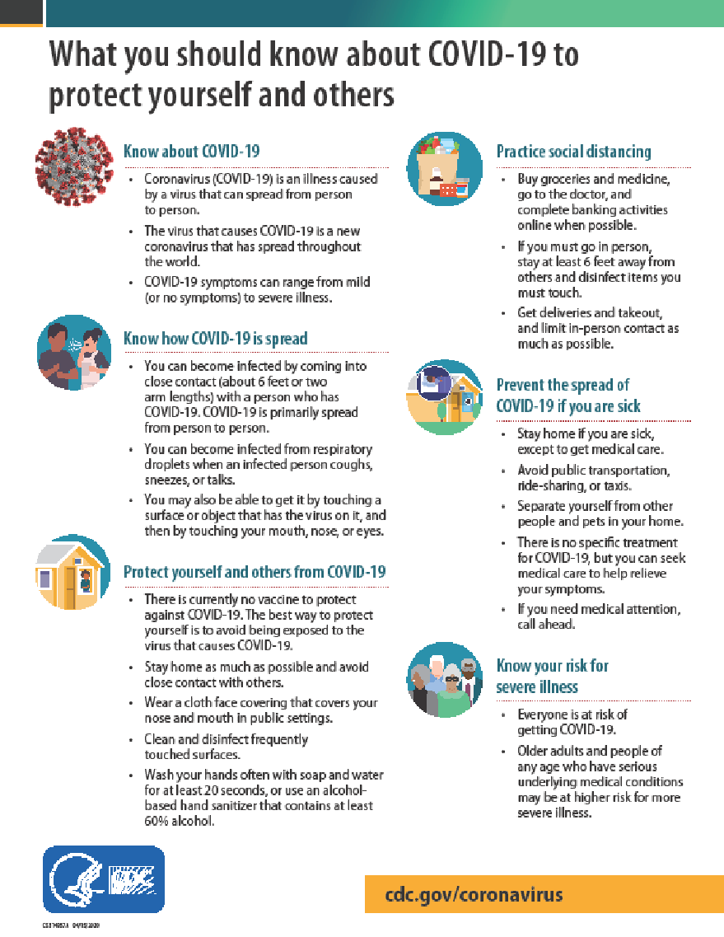

WHAT IS

CONTACT TRACING
?

BACKGROUND
Contact tracing is the process of reaching out to anyone who came into close contact with an individual who is positive for COVID-19. Contact tracing helps monitor close contacts for symptoms and to determine if they need to be tested. Contact tracing is a key strategy for preventing the further spread of infectious diseases such as COVID-19.

WHAT DOES THIS PROCESS LOOK LIKE?
- In contact tracing, public health staff work with a case to help them recall everyone they have had close contact with during the time they were infectious.
- Public health staff then inform individuals who have had close contact (e.g. “close contacts”) that they have potentially been exposed to COVID-19. Close contacts are only told that they may have been exposed to someone who has COVID-19; they are not told who may have exposed them.
- Close contacts are given education, information and support so they understand their risk. They receive information on what they should do to separate themselves from others who have not been exposed, how to monitor themselves for illness, and are made aware that they could possibly spread the infection to others, even if they do not feel sick.
- Close contacts will be asked to quarantine themselves and are encouraged to stay home and maintain social distancing through the end of their infectious period, which is about 14 days, in case they become sick. They should monitor themselves by checking their temperature twice a day and watch for any other symptoms of COVID-19. Public health staff will check in with these contacts to make sure they are self-monitoring and have not developed symptoms.
- If a close contact develops symptoms, they should isolate themselves and let public health staff know. The close contact will be evaluated to see if they need medical care. A test may be necessary unless the individual is already in a household or long-term care facility with a confirmed case, then the close contact would be considered a probable case without a test.

WHAT TERMS SHOULD I KNOW WHEN IT COMES TO CONTACT TRACING?
- A case is a patient who has been diagnosed with COVID-19. A case should isolate themselves, meaning they should stay away from other people who are not sick to avoid spreading the illness.
- A close contact is an individual who had close contact with a case while the case was infectious. A close contact should quarantine themselves, meaning they should stay at home to limit community exposure and self-monitor for symptoms.
- A contact of a close contact is an individual who had or continues to have contact with a close contact. A contact of a close contact should take all regular preventative actions, like washing hands, covering coughs and sneezes, and cleaning surfaces frequently. A contact of a close contact should be alert for symptoms.

RESOURCES:

NFHS: Guidance for Opening Up High School Athletics and Activities (per update on May 2020)

Centers for Disease Control and Prevention
Website: cdc.gov/coronavirus/2019-ncov/index.html
“What You Should Know About COVID-19 to Protect Yourself and Others”,
“Schools Decision Tree”

PA Department of Health
Website: health.pa.gov
“Coronavirus Symptoms”
“What is Contact Tracing”
“Phased Reopening Plan by Governor Wolf”

A Guide to Re-Entry to Athletics in Texas Secondary Schools
By Jamie Woodall, MPH, LAT, ATC, CPH and Josh Woodall Med, LAT, ATC

Guidance for All Sports Permitted to Operate During the COVID-19 Disaster Emergency to Ensure the Safety and Health of Employees, Athletes and the Public
https://www.governor.pa.gov/covid-19/sports-guidance/

Concession stands or other food must adhere to the Guidance for Businesses in the Restaurant Industry.
https://www.governor.pa.gov/covid-19/restaurant-industry-guidance/

Guidance for marching band activities:
https://www.nfhs.org/media/3812337/2020-nfhs-guidance-for-returning-to-high-school-marching-band-activities.pdf

